

Manual Import of an Image into the Fog Program

Prepared by: Robert Deans, Edited by Ray Pulsipher

You can manually copy a computer image into the FOG server. First you FTP the image, then you add an entry into the FOG server so it knows it is there.

1. To get the official laptop image go to: http://opedl.correctionsed.com/ope_lt_images/

2. Download the latest image (by date)

3. After is finishes downloading copy it to your external encrypted hard drive.

4. Extract the files to the same location (.image files are actually just tar.gz files, winrar can open these type of files, you can rename it if needed)

5. Move the external encrypted hard drive to the host of the Offline Server.

6. Open a FTP client on the Offline Server host. (Below example is using WINSCP)

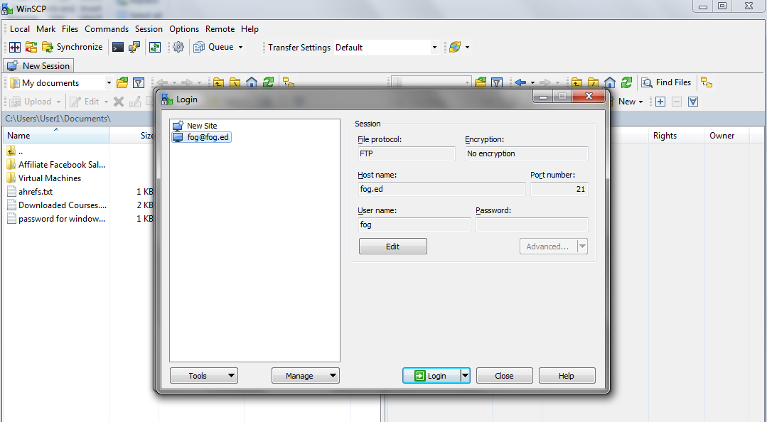

7. Set the FTP client to use passive FTP. Click "OK".

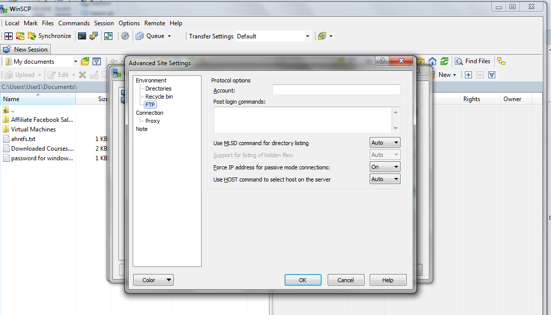

8. Go to the bottom of the login screen and click the "Login" box.

9. If the password box pups up enter the password for the fog server.

10. At the right side of the split screen double click the yellow fog folder.

11. Scan the listed folders and find the "Images" folder.

12. Double click the "Images" Folder.

13. Go back to the external encrypted hard drive and find the laptop image folder.

14. Right click laptop folder and choose copy from the dropdown list of options.

15. Return to the "Images" folder in the Offline server.

16. Right click the mouse in the white space on the right side of the split FTP screen and choose paste. This will insert the laptop image into the proper fog image directory for the deployment of the laptops.

17. Now, go to a computer that is on the same network as the Offline server and bring up a browser. Where you normally see a website URL , at the top of the screen, type in fog.ed. This will bring up the Fog imaging program.

18. Drag you mouse across the icons at the top of the page and stop at the icon the pops up the word "Images" below the icon. Click that icon.

19. Under the main menu at the left side of the page click "Create New Image".

20. Use the image below to fill in the boxes.

